Galiazzo Nicora

Project reflections:

This project is made In order to plan the budget of marketing for Gameco for the year 2017, Our task is to finds if the sales change on the regions or they stay the same as the board believe. In case these this assumption is not true we need to change the marketing budget adjusted by region.

In this project in order fulfil and maximize the return on investment of marketing department we will use the information from 2006 until 2016. I will use this Data because reflect the recent tendency of video game industry, this is a market related with technology and the changes and improves need to be taken in consideration to develop a correct analysis and understanding of the markets. Consoles and games from previous years are not being produced because the consoles finish their live cycle. My goal is to use the data set of these years to predict how every market around the globe interact whit the demand of each region and focus on the correct way the efforts of the company.

My approach to understand the relation of different market will begin with a analysis of market share during the period 2006-2016.

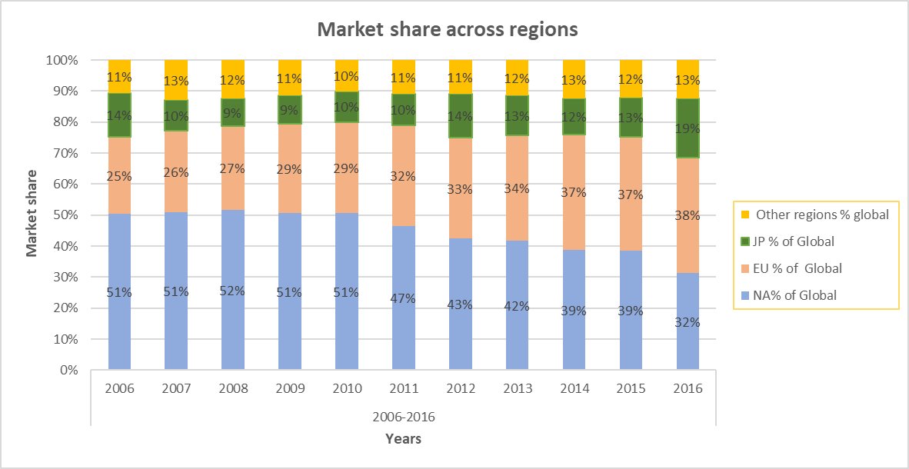

The data summary above shows the percentage of market share of all regions. At first glance I can deduct few trends on this graphic.

In this period of time we can observe how the participation of NA is going down since 2008, for further investigation we should investigate the causes of this decline. This trend continuous until 2016, being the main player to the second at the end of the analysis. For EU under the scope of observation is visible a growing in the market share, taking the first place for 2016. Japan in the other hand keep a market share that is constant trough this period, showing an increase in last year that can be explained by one title, that is not known in other regions.

Other markets with no further information have a behaviour that maintain in time.

After the analysis we can expect a growing in the market share in NA because of the data in the past, NA bust mostly USA present a big weight in the economy so is natural to infer this is a cyclic behaviour due the crisis of subprime where the most affected country was USA.

**Market and sales Analysis.**

It is primordial to understand the develop of the sales during the time, in the graphic we can observe a trend down, the sales across the markets reduce their volume. The 3 main markets show a similar curve, being other region is less affected by this trend down.

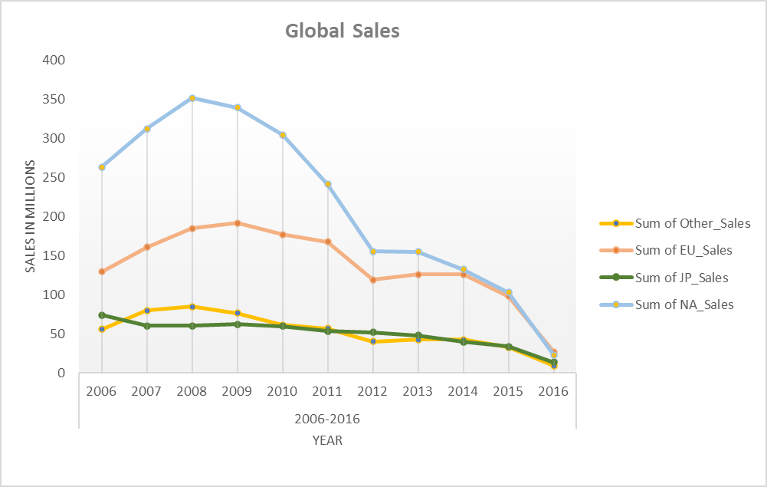

**Genre Analysis**

In this case we can observe what are the genres that are more popular by region, at first glance we can observe other regions show no particular preference for any genre being racing the favourite. JP have a high demand of RPG games, having around one third of the market for this games.In a similar approach For NA company will put more efforts in genres that are popular in the region, being shooter the dominant . For EU Racing is the more consumed genre in the period of analysis, preference in EU are close for all the genre beside Role-playing.

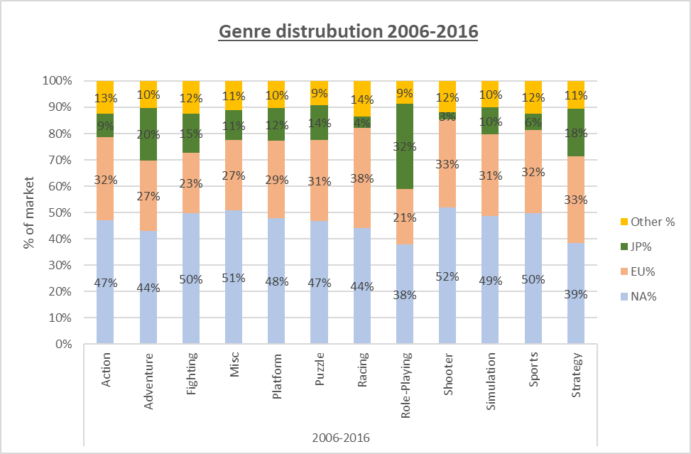

**Genre analysis by region 2016**

With the information exposed previously this are the recommendations for 2017 marketing budget:

* **NA**: IN this case we can observe a decline of the market share of this region, being 2016 the lowest year, in this region the most demanded genres are Shooter, action and sports games. This genres represent 79% of market by 2016.

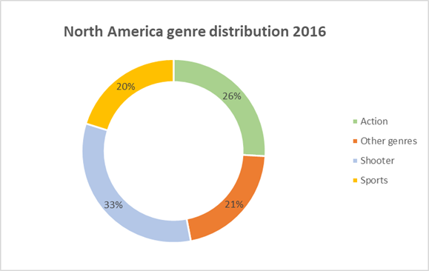

* **EU:** This is the market showing an increase in market share, an increase in marketing expenditure in Europe should be considered. Here is not a clear favourite in terms of genre but as same as in NA the 3 dominant genres are Shooter, Action and Sports.

* **JP:** Japan as the 2 previous regions experience a decline during the period of analysis and for or the last year increase the share. In this region we should focus on genres of Role-playing and action.

* **Other regions:** For the other regions I recommend keeping the current expenditure, since as the data indicate, these regions remain constant. It is a priority to maintain marketing expenditure in the action, sports, and shooter genres.

